Lesson 5:
Supination and pronation with extension and flexion: The forearm
Covering the ulna, radius and associated soft tissue
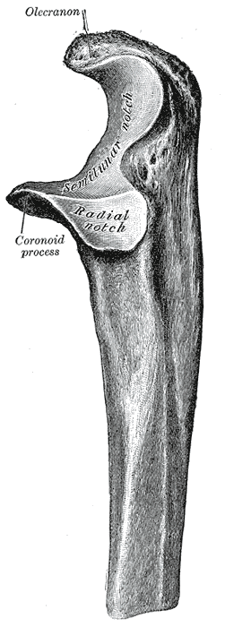

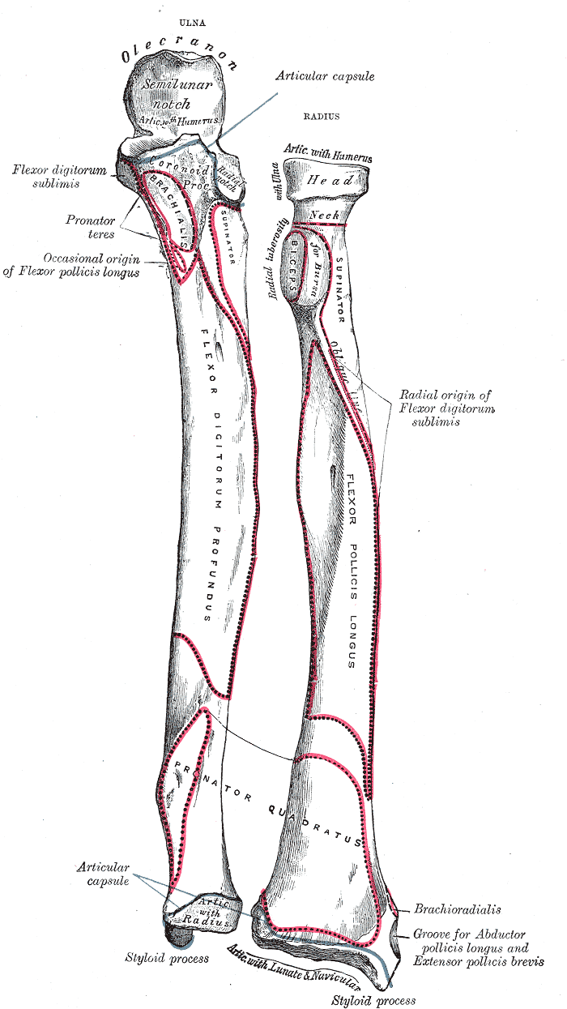
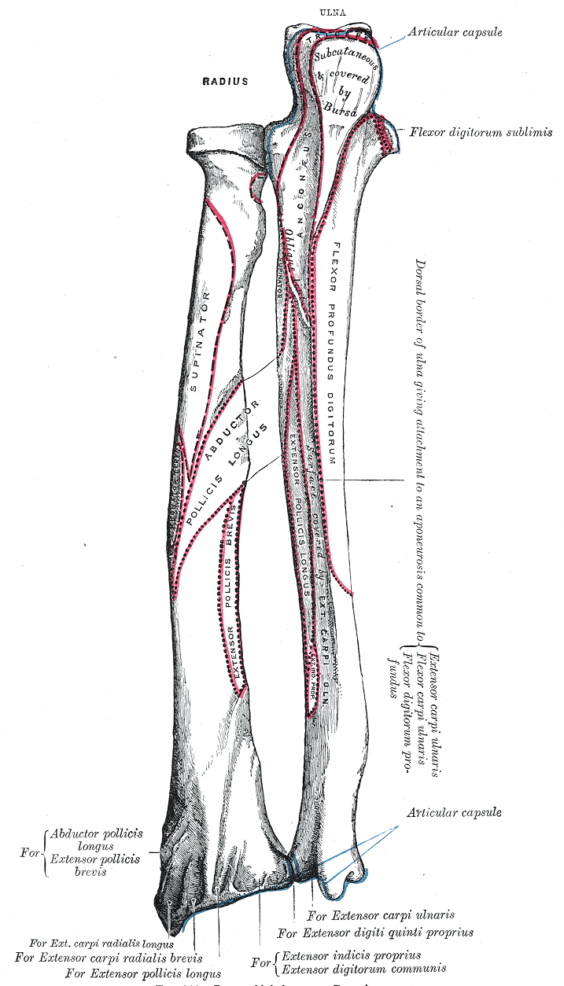

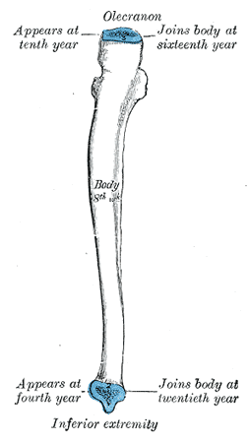 Plan of ossification of the ulna. From three centers.

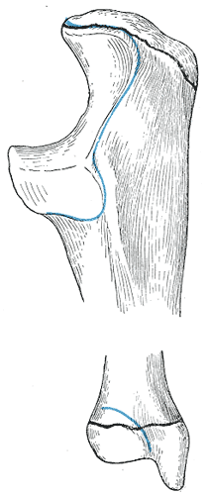 Epiphysial lines of ulna in a young adult. Lateral aspect. The lines of attachment of the articular capsules are in blue.

